**ITC Hotels Revenue Optimization**

**Prepared by: Priyansh Bhangalia**

Problem Statement:

ITC Hotels is a luxury hotel chain that operates multiple properties with diverse room categories and varying occupancy rates. The company wants to gain deeper insights into its overall financial performance, customer booking behaviour, occupancy trends, and room category performance to optimize revenue generation, minimize cancellations, and enhance customer satisfaction. The goal of this project is to create an interactive, multi-page Power BI dashboard to provide stakeholders with real-time insights for decision-making.

Dashboard:

1. Financial Overview & Revenue Performance

2. Occupancy & Capacity Analysis

3. Room Category Performance & Booking Insights

4. Cancellations & Lost Revenue Analysis

**1.Financial Overview & Revenue Performance:**

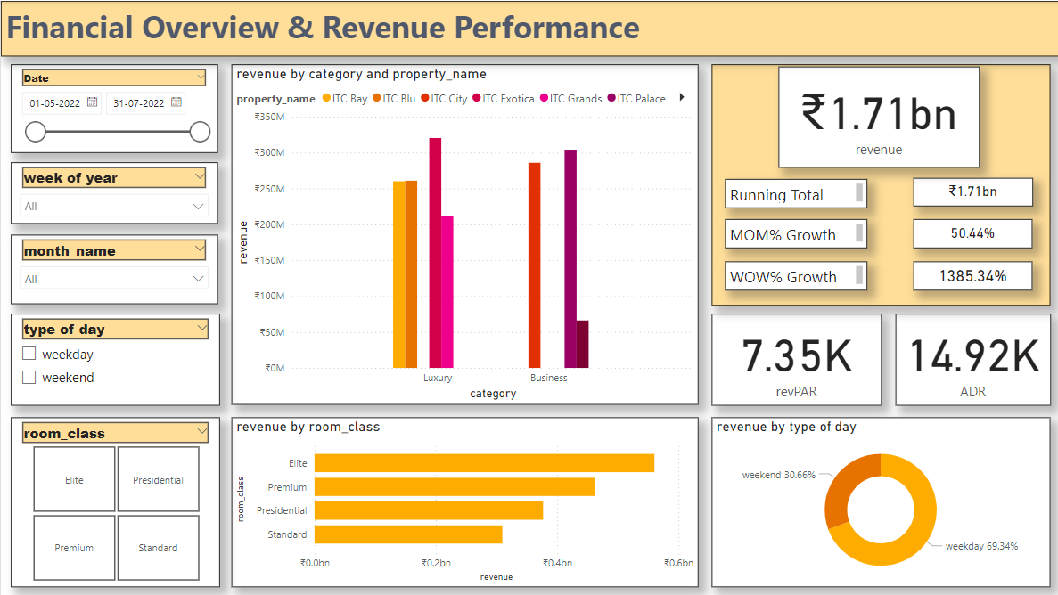

This Power BI dashboard offers a comprehensive view of financial and revenue performance for a hospitality business. Here's a breakdown of its features:

**Key Insights**

1. **Revenue Overview**:
   * Total Revenue: ₹1.71 billion is highlighted prominently.
   * **Metrics**:
     + Month-over-Month (MOM%) Growth: 50.44%
     + Week-over-Week (WOW%) Growth: 1385.34%
   * Performance indicators like **RevPAR (₹7.35K)** and **ADR (₹14.92K)** are displayed.
2. **Visualizations**:
   * **Revenue by Category and Property Name**:
     + Bar chart showing revenue distribution for Luxury and Business categories by property.
   * **Revenue by Room Class**:
     + Bar chart for revenue breakdown by room types such as Elite, Premium, Presidential, and Standard.
   * **Revenue by Type of Day**:
     + Donut chart showing the percentage split between weekdays (69.34%) and weekends (30.66%).
3. **Filters and Slicers**:
   * Date Range: Allows users to filter data from May 1, 2022, to July 31, 2022.
   * Week of Year, Month Name, Type of Day, and Room Class: Provide additional filtering options for granular analysis.

**2.Occupancy & Capacity Analysis:**

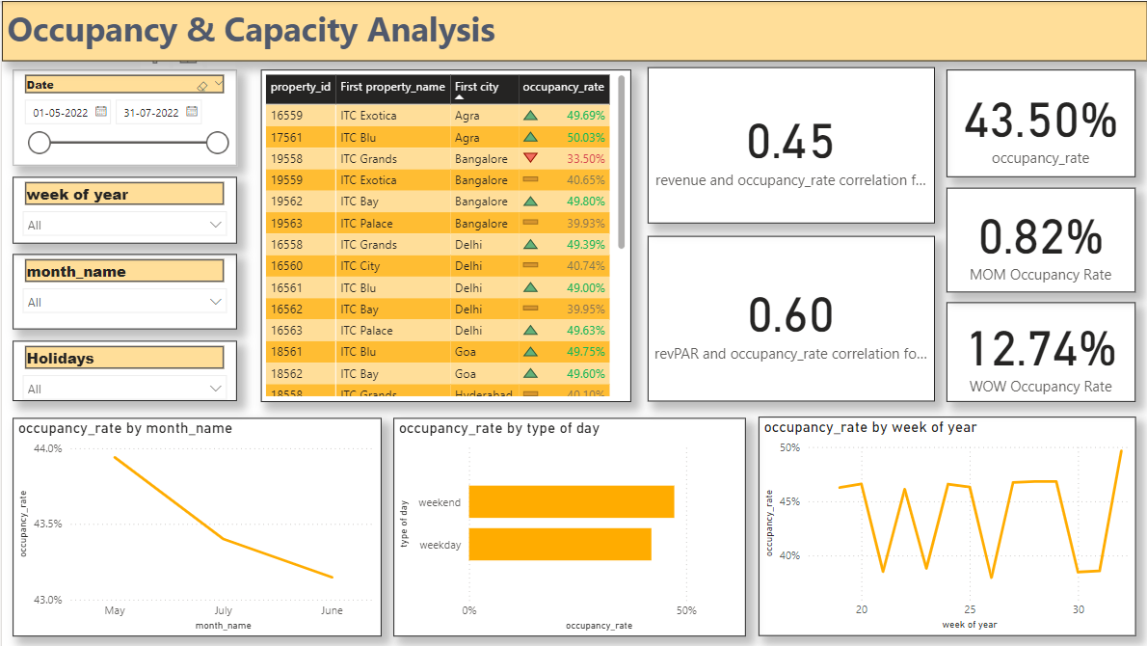

This dashboard focuses on **Occupancy & Capacity Analysis**, providing an overview of property performance based on occupancy rates. Here's a breakdown of its features:

**Key Metrics and Insights:**

1. **Core Metrics**:
   * **Occupancy Rate**: 43.50%
   * **MOM Occupancy Rate**: 0.82%
   * **WOW Occupancy Rate**: 12.74%
   * **Correlation Metrics**:
     + Revenue & Occupancy Rate: 0.45
     + RevPAR & Occupancy Rate: 0.60
2. **Visualizations**:
   * **Occupancy Rate by Month**:
     + A line chart showing a decline in occupancy rates from May to July.
   * **Occupancy Rate by Type of Day**:
     + Bar chart comparing weekday and weekend performance, with weekends performing better.
   * **Occupancy Rate by Week of Year**:
     + A line graph showcasing weekly occupancy trends.
3. **Property Details**:
   * Table displaying:
     + **Property ID**, **Property Name**, **City**, and **Occupancy Rate**.
     + Includes icons to indicate changes (e.g., upward or downward trends).
4. **Filters**:
   * **Date Range**: Allows analysis for specific periods (May 1, 2022, to July 31, 2022).
   * Additional filters: **Week of Year**, **Month**, and **Holidays** for deeper insights.

**3.Room Category Performance & Booking Insights:**

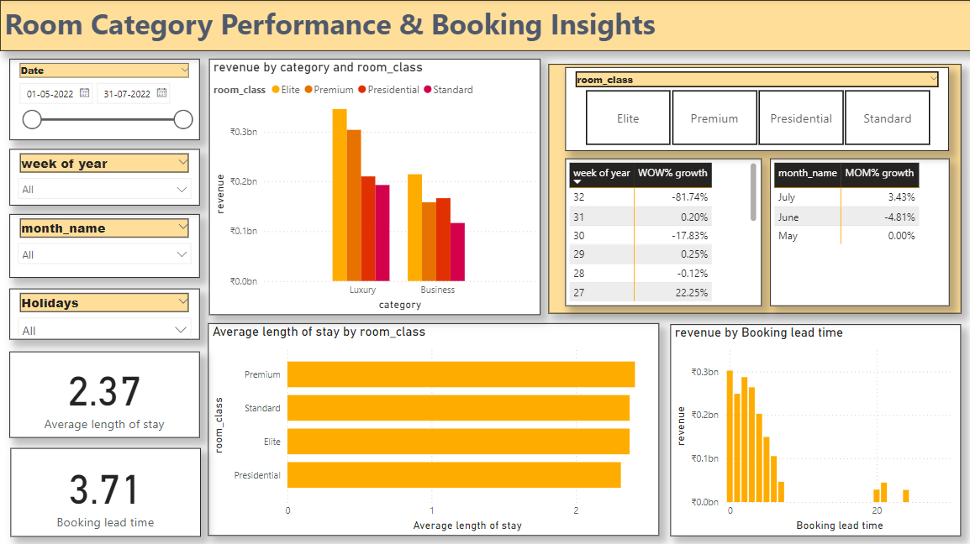

This dashboard provides insights into **Room Category Performance & Booking Trends**, focusing on revenue, growth, and customer behaviour. Here's a breakdown of its elements,

**Key Metrics and Insights:**

1. **Summary Metrics**:
   * **Average Length of Stay**: 2.37 days.
   * **Average Booking Lead Time**: 3.71 days.
2. **Visualizations**:
   * **Revenue by Category and Room Class**:
     + A grouped bar chart showcasing revenue distribution across room classes (Elite, Premium, Presidential, Standard) for Luxury and Business categories.
   * **Revenue by Booking Lead Time**:
     + A histogram showing revenue contributions based on booking lead time, emphasizing short booking windows.
   * **Average Length of Stay by Room Class**:
     + Bar chart illustrating that Premium and Presidential guests tend to stay longer.
3. **Growth Metrics:**

* Table showing monthly and weekly trends of room revenue with respect to room class.

1. **Filters**:

* Slicers for **Date**, **Week of Year**, **Month**, **Holidays**, and **Room Class**, enabling detailed exploration.

**4.Cancellations & Lost Revenue Analysis:**

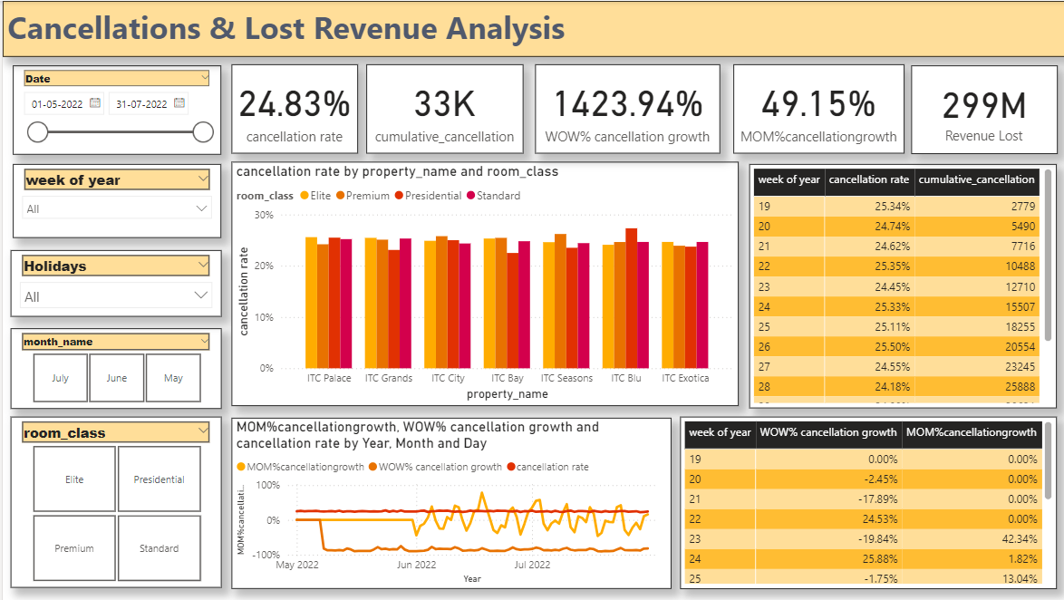

The dashboard you’ve shared appears to analyse cancellations and lost revenue for a hospitality or property management business. Key features include:

1. **Key Performance Indicators (KPIs):**
   * **Cancellation Rate**: 24.83%
   * **Cumulative Cancellations**: 33K
   * **WOW% Cancellation Growth**: 1423.94%
   * **MOM% Cancellation Growth**: 49.15%
   * **Revenue Lost**: 299M
2. **Filters:**
   * Date range, week of the year, holidays, month, and room class.
3. **Charts and Tables:**
   * A bar chart displaying cancellation rates across properties segmented by room class (Elite, Premium, Presidential, Standard).
   * Line chart showcasing trends in MOM%, WOW%, and cancellation rate over time.
   * Tables summarizing weekly cancellation rates, cumulative cancellations, and growth rates.